**Concept Development**

**Problem Statement**

Video games need a better way to include a challenging, immersive, and unique experience at an affordable price.

**Proposed Idea**

The Muscle Gaming Machine (MGM) is a handheld gaming device that is controlled primarily through sensing muscle contractions. This will allow users to encounter a unique and intense gaming experience. The MGM features biomedical sensor pads that can sense multiple levels of muscle contraction, multiple games, and a long-life LiPo rechargeable battery.

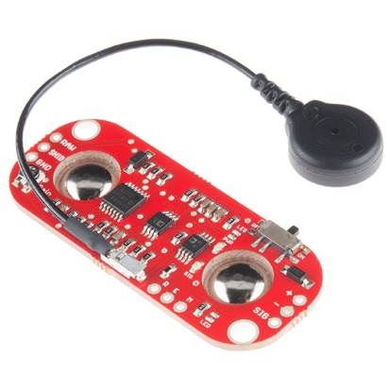**Influences**

This is the **MyoWare Muscle Sensor**, an Arduino-powered, all-in-one electromyography (EMG) sensor from Advancer Technologies. The MyoWare board acts by measuring the filtered and rectified electrical activity of a muscle; outputting 0-Vs Volts depending the amount of activity in the selected muscle, where Vs signifies the voltage of the power source.

<https://www.sparkfun.com/products/13723>

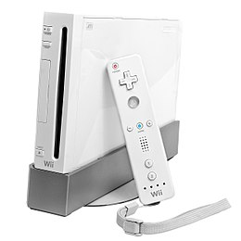

**Nintendo Wii**

The Wii introduced the Wii Remote controller, which can be used as a handheld pointing device and which detects movement in three dimensions.

<https://en.wikipedia.org/wiki/Wii>